**Image Gallery Website with Firebase Authentication and Realtime Database**

Name: Nithin L

Roll No: 21i231

Branch: B.Tech - Information Technology

**Hackathon Problem Statement : Q2) Build a Image Search app using Unsplash APIs. You can build mobile or web apps using iOS/React - Native/Kotlin/React/Node etc.**

1. **Introduction:**

This website is an image gallery platform that utilizes the Unsplash API to display images based on user queries, integrates functionalities such as real-time object detection, user authentication, and personalized search history.Detect objects using **TensorFlow.js a pretrained model** for object detection, it allows users to upload images, detect objects, and search for related content.Incorporating **Firebase** for user authentication and Realtime Database for storing data such as UserName,Email,Search History and Bookmarked Images. The site also features a dynamic, user-friendly interface with responsive design powered by **Bootstrap** and JavaScript, enhancing the overall user experience.

**2. Functionality Report:**

#### 2.1. ****User Authentication & Profile Management****

* **Firebase Authentication** is used to manage user accounts, login, and sign-out functionality. The current user’s UID is retrieved from Firebase for personalized data search using search history.

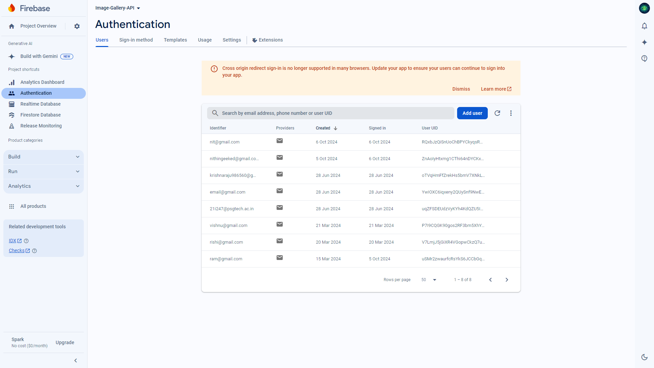

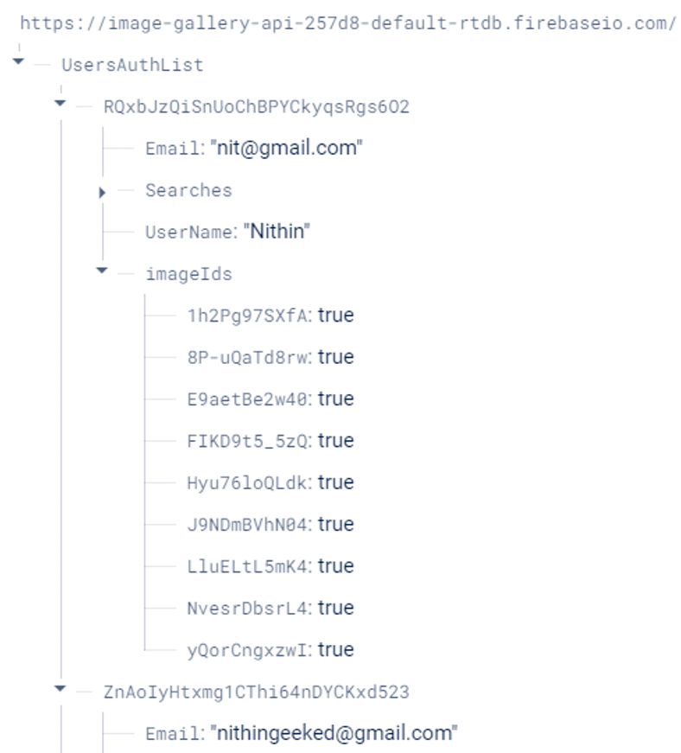 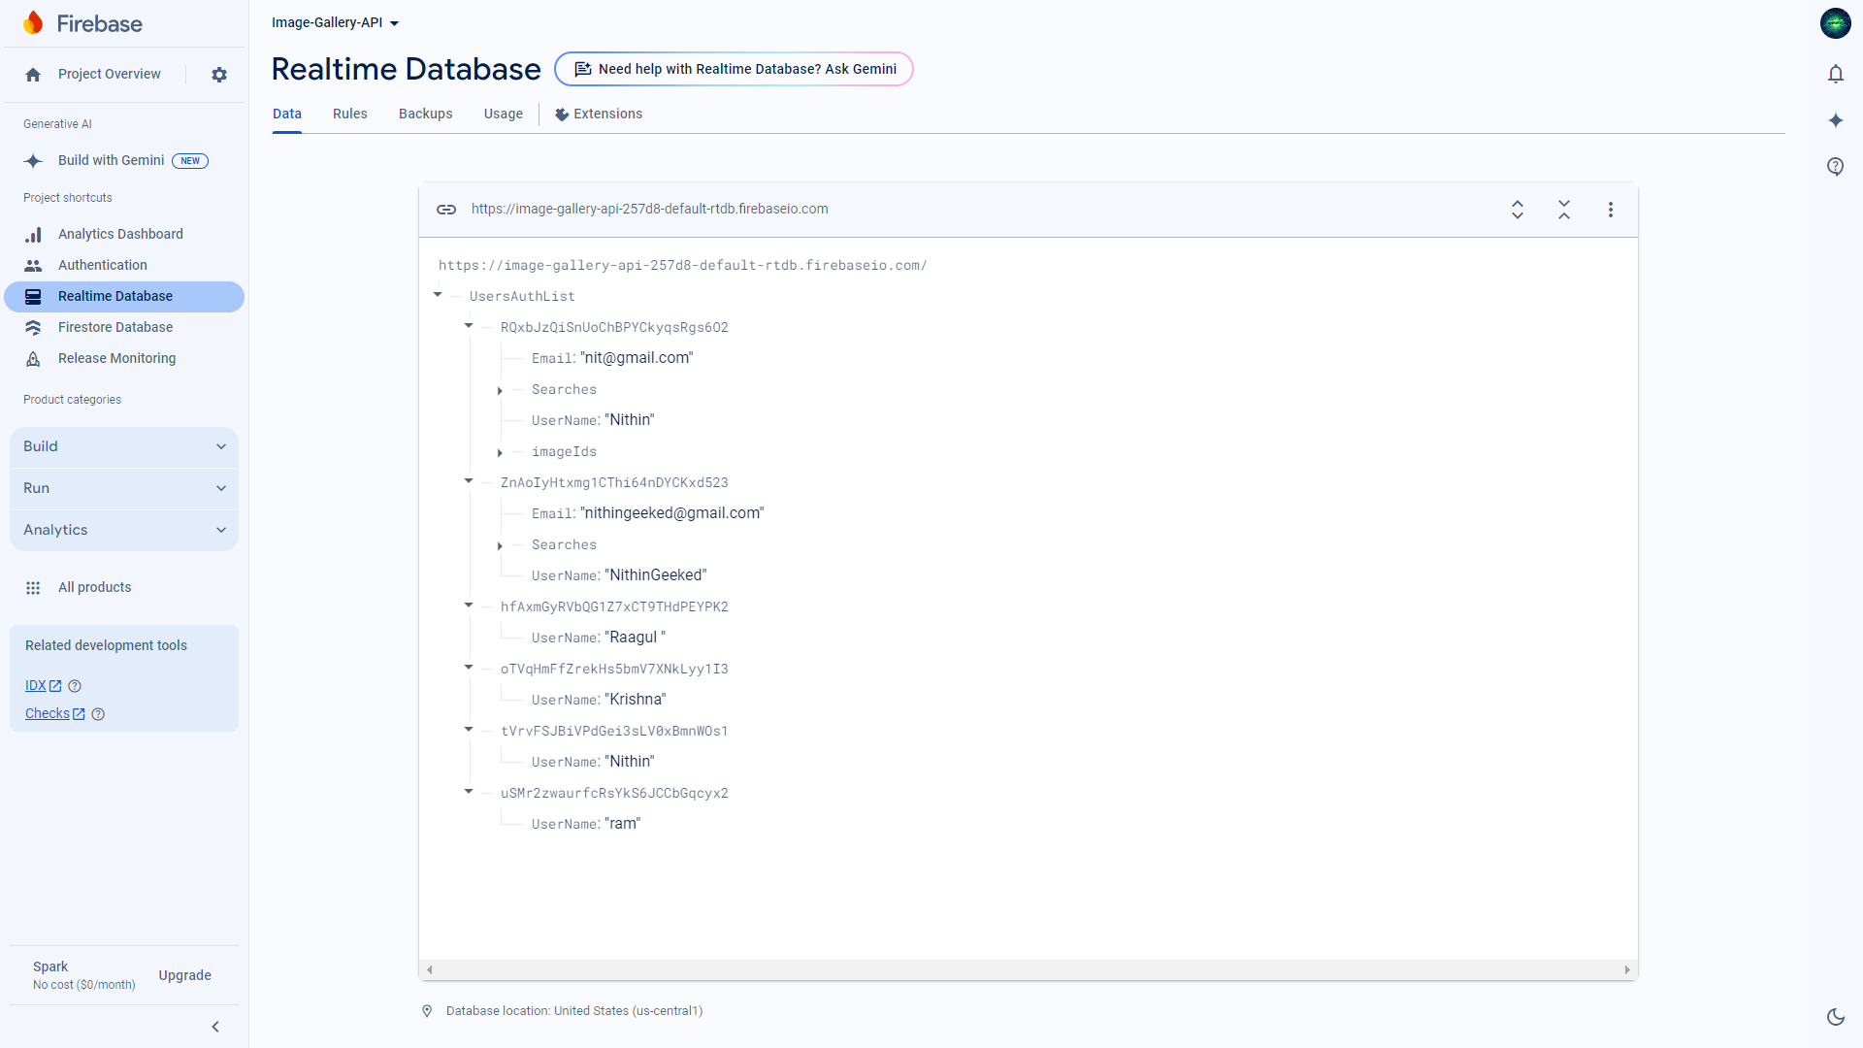

* **Profile Icon & Dropdown:** The profile icon is clickable, and it displays a dropdown menu for user actions. The dropdown can be toggled, and it automatically closes if clicked outside.

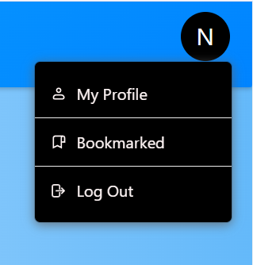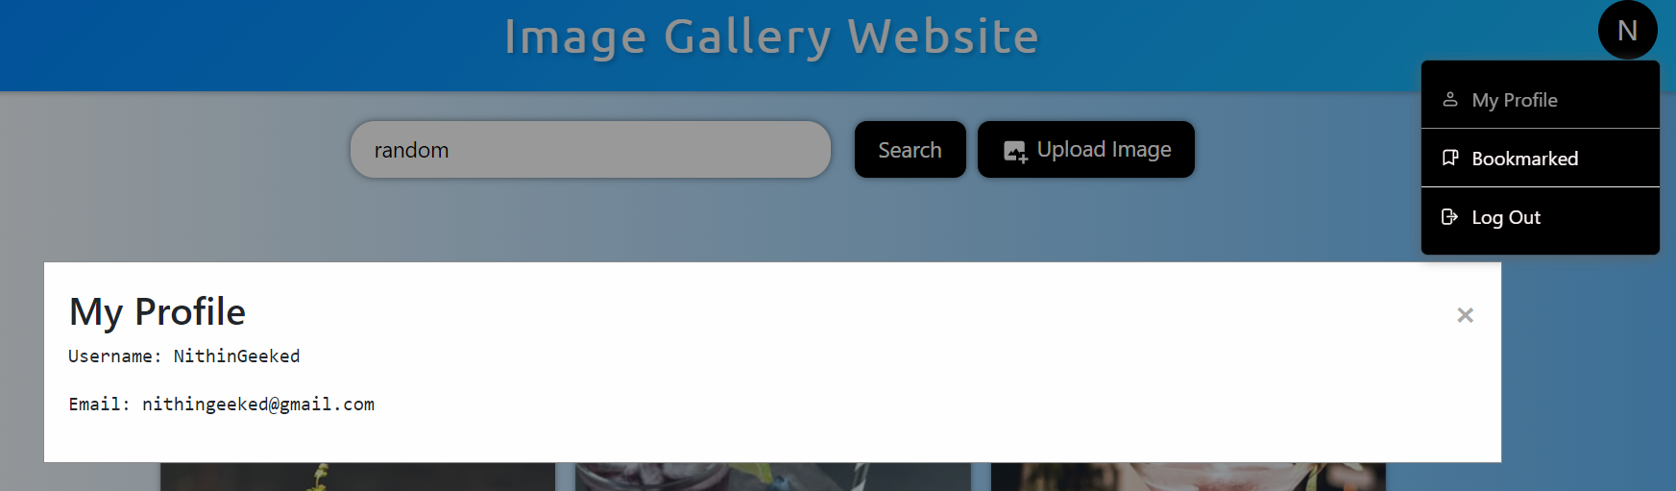

#### 2.2. ****Image Detection with TensorFlow.js****

* **TensorFlow COCO-SSD Model** is integrated to perform real-time image detection on user-uploaded images. When an image is uploaded:
  + It processes the image using TensorFlow's COCO-SSD object detection model.
  + Detects objects and displays the label of the first detected object.
  + Automatically inputs the detected object label into the search bar and triggers a search.

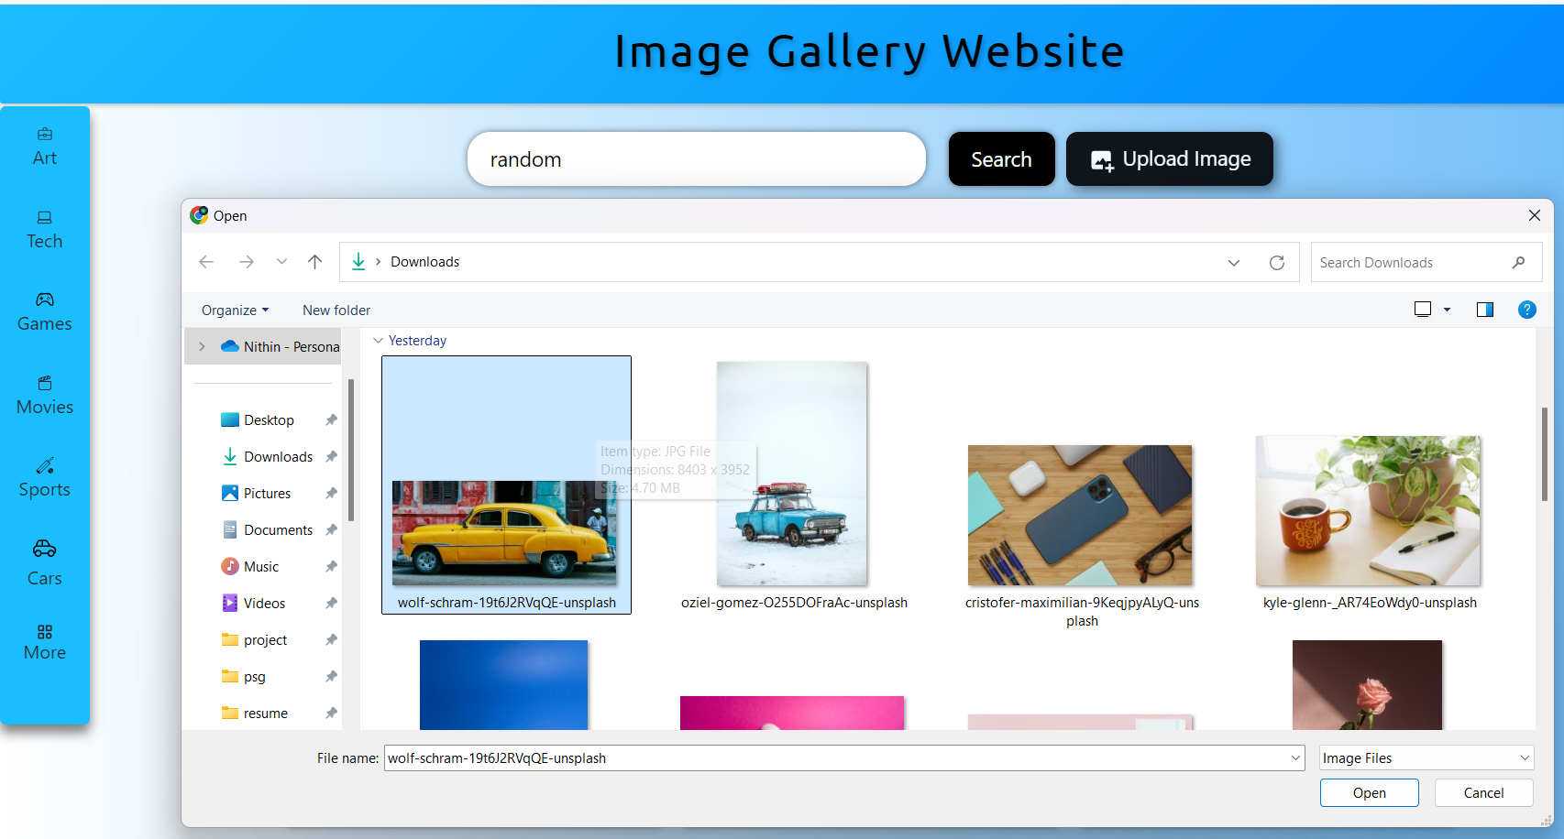

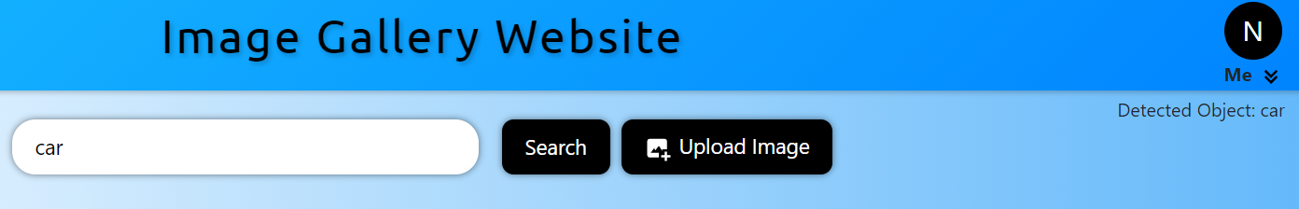

#### 2.3. ****Image Search and History****

**Image Search Functionality:**

* + Users can search for images by typing search terms or using the detected label from uploaded images.
  + The search term is normalized (converted to lowercase) before saving and processing.
  + The system prevents duplicate search terms and limits the search history to the last 10 unique searches.
  + Search results are dynamically displayed based on the input, including random image display functionality.

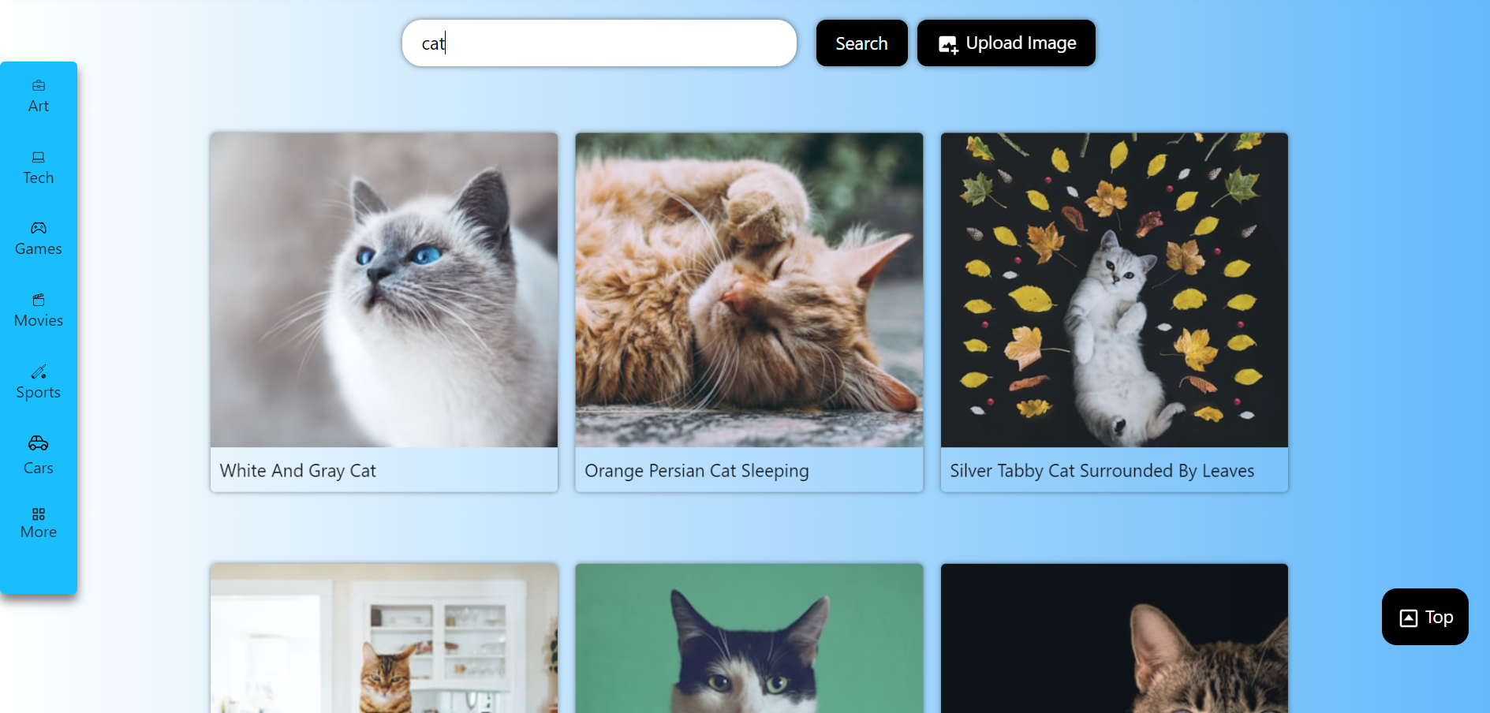

**Search History Management:**

* + The website stores the user's search history in **Firebase Realtime Database** under the user's data.
  + Searches are saved in the Searches list under the user's profile, and duplicate entries are avoided.
  + If a new search term is detected, it is added to the search history after the current user data is fetched from Firebase.

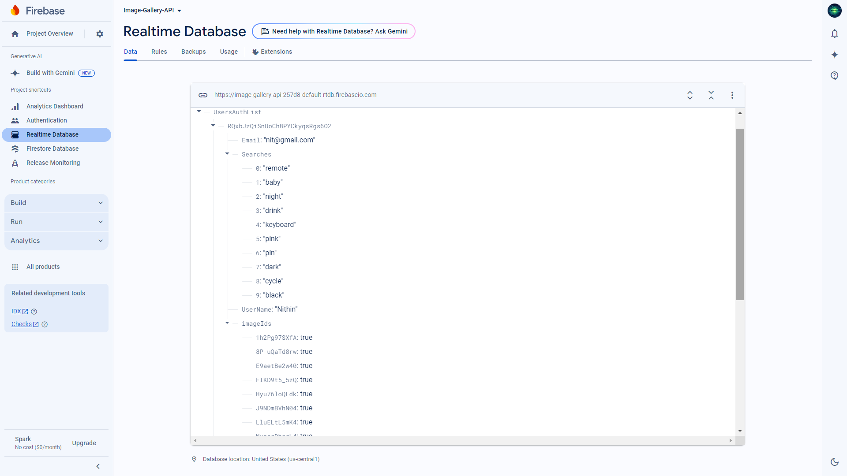

#### 2.4. ****Image Gallery Logo/Header****

* The **image gallery** displays random images, leveraging the website’s backend to show images related to search terms. It’s designed to load dynamically when the user interacts with the gallery.



#### 2.5. ****User Interface (UI) Features****

* **Search Button:** Users can manually click the search button, or it’s automatically triggered after an object detection event.
* **Top Button:** A "Scroll to Top" button appears when the user scrolls down, enhancing the navigation experience.
* **Popup Management:** The website includes popup elements to show messages or additional information to the user. These popups are styled using CSS and controlled by JavaScript.
* **Responsive Design & Animations:** The site uses **Bootstrap 5.2** for a responsive layout, ensuring a clean UI across different screen sizes. Hover effects and animations are added to enhance interactivity.
* **Bookmark/Saved Icon:** This icon allows users to save their favorite images for easy access later, enhancing their browsing experience by providing quick navigation to preferred content.
* **Download Icon:** The download icon enables users to conveniently download images to their devices, facilitating seamless sharing and offline access to their favorite visuals from the gallery.

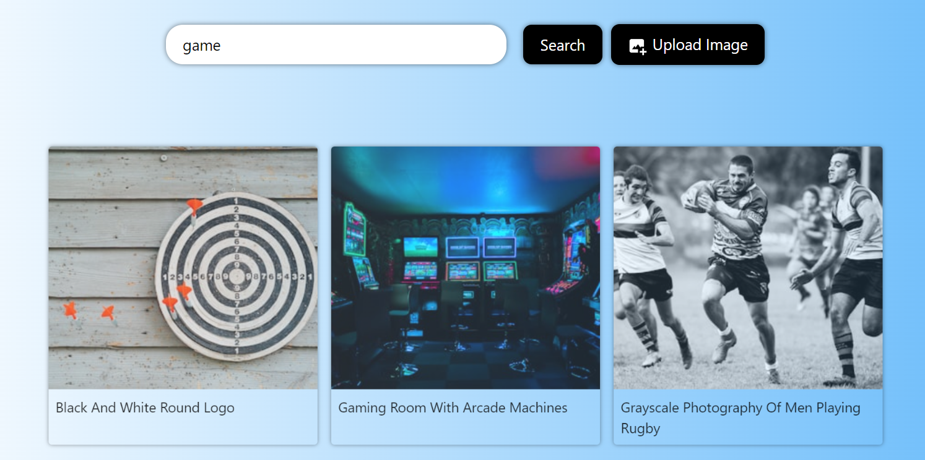

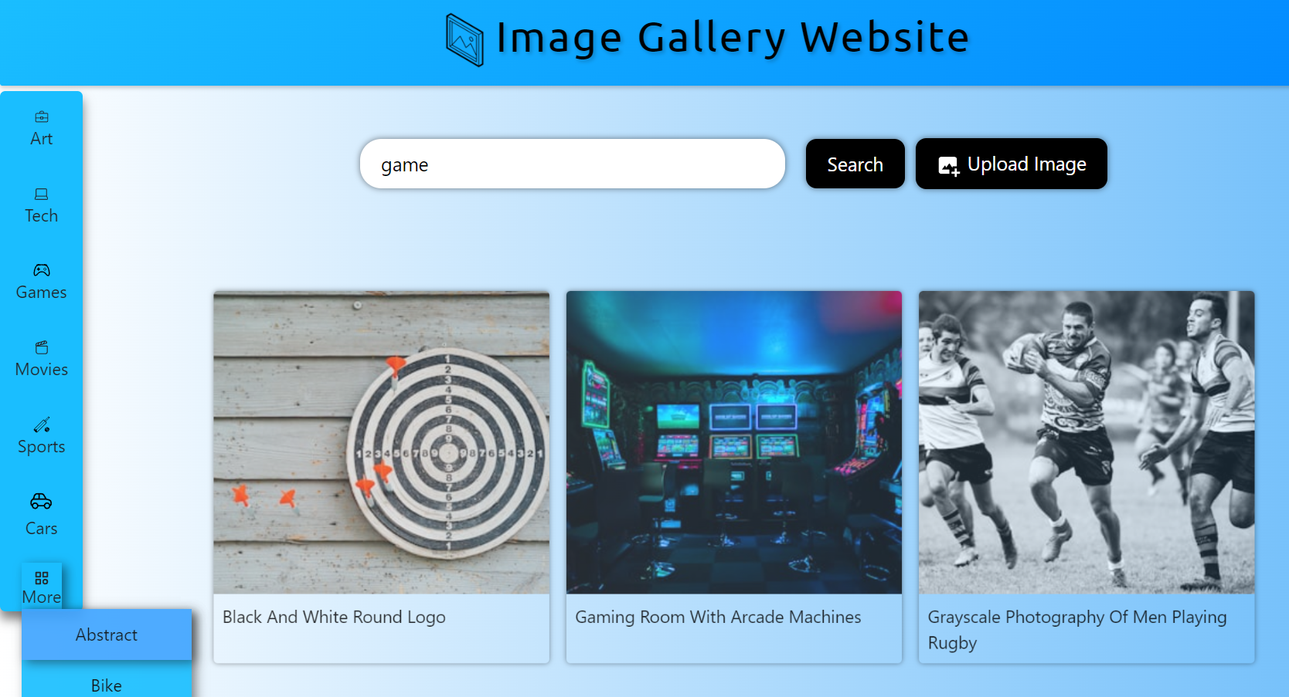

#### 2.6. ****Session Management****

* **Session Storage**: User sessions and profile information are maintained using **JavaScript session storage**. This enables user-specific data to be available across page loads and helps manage user authentication status.

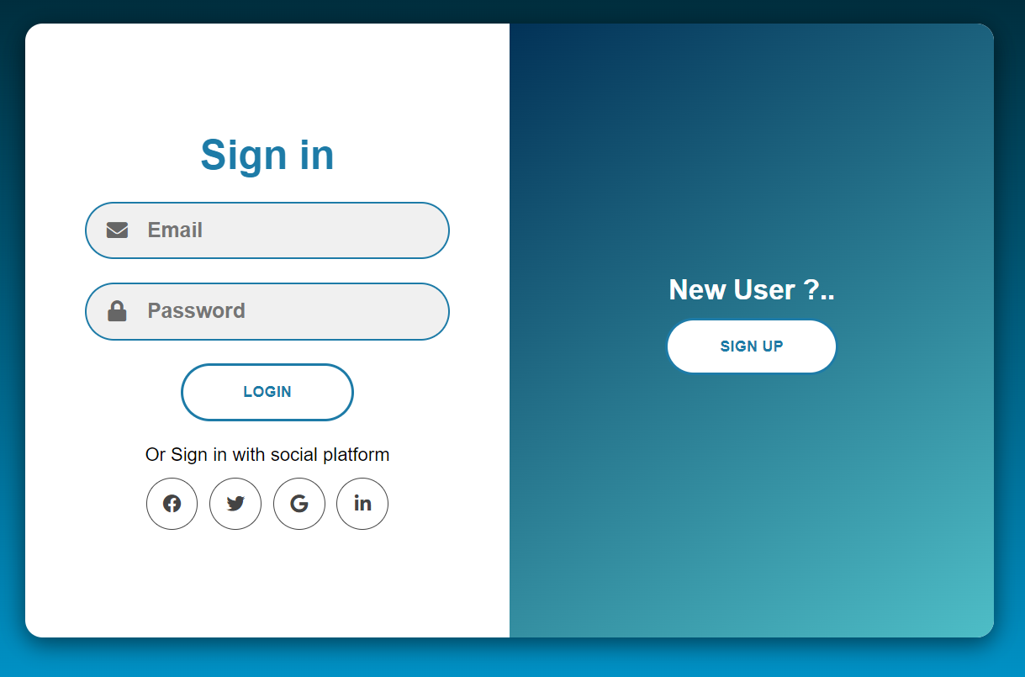

 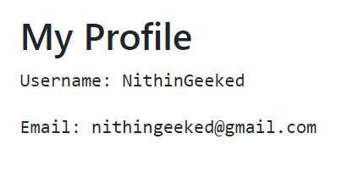

#### 2.7. ****Sign-out Functionality****

* A **sign-out button** enables users to securely log out, which redirects them to the homepage (index.html) and clears session data.

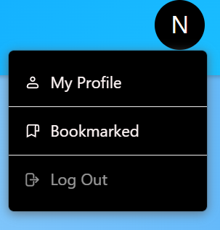

#### 2.8. Unsplash API - ****JavaScript Functions****

* The Unsplash API enables dynamic retrieval of high-resolution images through various endpoints, including search and photos, which require authentication via an API key.By utilizing JavaScript, you can make API requests to the Unsplash endpoints based on user interactions.Once you receive the API response, you can parse the JSON data to extract relevant information (such as image URLs, alt text, etc.) and update your HTML content dynamically using JavaScript.

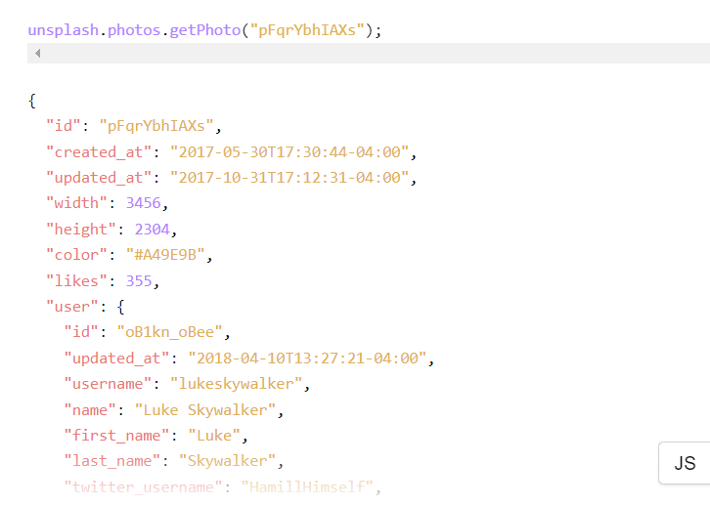

#### 2.9. ****Error Handling****

* **Firebase Error Handling:** In case of any errors while fetching or saving user data, appropriate error messages are logged to the console.
* **No Object Detected:** If no objects are detected in an uploaded image, a message informs the user that no object was found.

### Technologies Used:

* **Frontend:**
  + HTML5, CSS3, JavaScript (Vanilla JS and ES6+)
  + Bootstrap for responsive design.
  + TensorFlow.js for object detection.
* **Backend:**
  + Firebase Realtime Database for storing user data, search history, and authentication.

### Conclusion:

The website integrates advanced technologies like TensorFlow for real-time image detection, Firebase for user management and search history, and a clean UI design for an intuitive user experience. It is built to offer efficient search functionalities, personalized user sessions, and dynamic UI components.